Kennoway Star Hearts Football Club Ltd
Welcome Pack
Prepared for: Club Members
Prepared by: Kennoway Star Hearts Football Club Ltd Committee
Date Updated: 2nd October 2025

w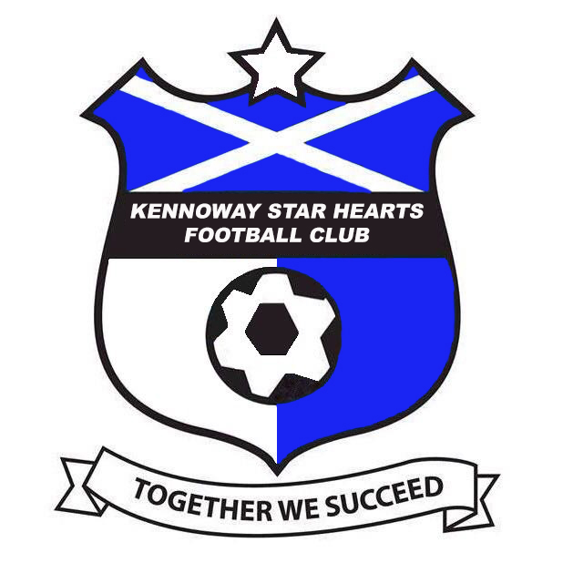
Kennoway Star Hearts Football Club Ltd would like to welcome you to your Club & ours. We hope that your time with us shall be as successful as it can be and most of all, enjoyable.

Background

In 2018 it was decided to bring all Kennoway Football Clubs together that wished to, and form one big club named Kennoway Star Hearts Football Club. The clubs that joined were the Fun 4’s & 5’s, Soccer 7’s and the older 11 a side teams as well as one of the Amateur sides. A pathway was created to Thornton Hibs JFC (Seniors) who at the time, play in the First division of the East of Scotland Football League which is part of the SFA Pyramid system.

An executive Committee was elected with the task of taking the whole club forward. It was decided early in the transition to at some point get girls football up and running and affiliated to the club as well as an ever-growing demand for an Over 35’s team. We now have a dedicated pathway for our girls section to the recently formed Thornton Hibs Ladies.

The Executive Committee is made up of –

Chairman
Vice Chairman
Secretary
Treasurer
Children’s & Wellbeing Officer
Communications Officer
PVG Co-Ordinator
+ 2
Coach Development Officer

The Committee meets approx. every 10-12 weeks to discuss and vote on any business that is brought to the attention of the board.

Each age group can have their own committee who can then report back to the Executive Committee if they deemed necessary.

Monthly Fees
The monthly fees that each playing member shall pay will be set by the Executive Committee at the AGM held each year and after consultation with each group. Age groups who have to budget for match day referees shall always pay more each month to cover the cost of this.
Fees shall be paid monthly on or as near the 1st of each month by Direct Debit directly into the club bank account. The fees each month will cover the cost of coaching courses, first aid courses, facility hire, insurance, and team registrations to any governing bodies it also covers any equipment required and the upkeep of our Pitches and facilities.

We as a club endorse and fully support ‘Codes of Conduct’ and are available to read over via or dedicated website. Each age group should ensure these are signed by each player and parent or guardian. A copy will be retained by the club and shall be available at any time to be audited by the Executive Committee and the SFA.
The clubs ‘Codes of Conducts’ binds the coaches as well, who should sign these forms also.

Coaches
All coaches MUST hold a current & valid SFA PVG certificate, as well as anyone who has any dealings at all with the kids. Without an actual hard copy of this, no one shall be permitted to coach or have any participation with the kids. This certificate is a requirement by law and to take part in any kind of ‘official team/club duties’ without a current PVG is a crime as from the 1st September 2025.

All coaches should have a valid coaching certificate to coach the level that they are coaching. If not, then they must be seen as willing to attend a course subject to availability to the course and themselves. All courses up to and including 1.3 will be paid for by the Club.

We actively seek parent / guardian helpers, without these, our Club would not be able to function. If a PVG is required to the role that someone is volunteering for and it requires a PVG, this shall be at no expense to the person, as the Club shall cover the cost.

If any Coaches are subject to any form of disciplinary measures by governing bodies and they receive a monetary fine for indiscipline for actions off the pitch, this will be paid for by the Coach in question so as not to deflect any monies that the kids have.

All age group head coaches are the persons in charge of the running of their team. Any issues should be directed to them first. The head coach will decide when a playing member is given any Kennoway Star Hearts Football Club Ltd kit.

The Club kit is as follows –

Home – Royal Blue
Away – Black
Training Top – Black
Fun 4’s & 5’s – Black (Same as training top)

Training Kit will be provided by the team and will be allocated by the head coach or in their absence, the teams secretary.
We expect the Kit given out to be looked after and to be returned (if necessary) in good condition.
If any playing member leaves the Club, then ALL kit that has been given to them MUST be returned, no player shall be released until the Head Coach is satisfied that all kit has been returned and in good condition. Parents / Guardians will be held liable to a charge to replace any kit returned damaged or missing.

If a Team decides to leave or worst case are asked to leave then all Playing Kit / Coaches Kit / Footballs / Keys and equipment must be returned to Kennoway Star Hearts Football Club (Owners) only items exempt are any items that were bought personally and were not paid for by the Club or the Clubs money.

Anyone wishing to purchase additional Club kit is more than welcome to. Should you require any more information, then please speak to the Head Coach or Secretary.

Fundraising
Throughout the year we do fundraising events for the age groups, we do expect coaches, committee, helpers, parents and guardians to assist with this when they can. If a certain players parents or guardians continue to not take part in these or assist, then any monies raised on the day / evening will not be shared to that playing member. We have to ensure as much fairness across the board.

If any age group or person leaves the Club, then the money raised from any Fundraising stays with the Club as all Fundraising is carried out in the name of Kennoway Star Hearts Football Club Ltd.

During the year, different age groups will take part in various festivals throughout Scotland and at times, further afield. An overnight stay may be required, parents / guardians will be required to accompany their child to these festivals.

Complaints
Any complaints that anyone makes will be taken seriously and investigated properly. At all times, you can be assured that these will be handled with the strictest confidentiality. We have a dedicated Children’s & Wellbeing Officer who will look into all aspects of any complaint whatever it may be.

What should you expect from us for your child –

As a Club, we shall provide a safe & friendly environment for your child to come and have fun. This includes safe equipment, a stocked first aid kit, and qualified coaches. We shall provide a training kit (Top, shorts, socks & ¼ zip top), match day kit (top, shorts & socks). If any kid grows out of their kit, the Club shall replace. All kids will be treated fairly no matter their ability or backgrounds. We as a club will NOT tolerate bullying in any form.
We shall let everyone know if any training or matches are off as soon as possible.

What do we as a club expect from you –

- We expect you to abide by our Club rules, respect your teammates, coaches and the opposition (including parents / guardians as well as coaches).
- If any player loses any of their issued kit, we expect you to replace it with no detriment to the team; we also expect all kit to be looked after.
- If you can’t make a training session or a game, then please inform your head coach as soon as reasonably possible.
- As previously stated, if anyone decides to leave the club, then we require ALL kit that was supplied to be returned to the head coach.
- Only once this has been done and that the head coach is satisfied that it has been returned in good condition will the player be released from Kennoway Star Hearts Football Club

Games / Festivals
Actual games /festivals predominately take place at weekends, however, at times this may change due to school holidays, we as a club will give as much notice as possible as to when and where these shall take place.

It is the coach’s decision who plays and attends games. This may be decided by behaviour, attendance at training etc., but ultimately it is the coach’s decision.
If for any reason you as a parent / guardian are unhappy at your child not being selected, we appreciate it if you speak to the coaches after training and not during a game (UNLESS OF A SERIOUS NATURE). The same goes for kids starting games and maybe being a Substitute, this is the head coach’s decision. All kids no matter ability, will be treated the same when it comes to games and game time.

But most of all, we want any member of the club to come along and enjoy, we welcome everyone.

E-mail – kennowaystarheartsfootballclub@gmail.com

